Borislav Georgiev

INF240b

Project 2 – Business Website

I, Borislav Georgiev, state that the submitted assignment is all my own work; I did not copy the material from someone else; I did not use any Web design software; no one but me developed the web site.

I have successfully completed the assignment.

____________________ ____________________

/Signature/ /Date/

**The URL of my work is:** <http://home.aubg.bg/students/BAG130/INF240/INF240%20Project%202%20Borislav%20Georgiev/index.html>

The design of my website is rather simple but at the same time stylish, I would say. All pages consist of a header with logo and navigation. The background image is sourced from the internet by URL. The width of all the containers is set to 70%. There is also a semi-transparent background to the container with id content which provides a bit more readability. The font is custom set with @font-face. There is a hover property for the logo and the navigation. It is a steady change in color that changes fully for 0.3 seconds (looks smooth)

**The Home Page**

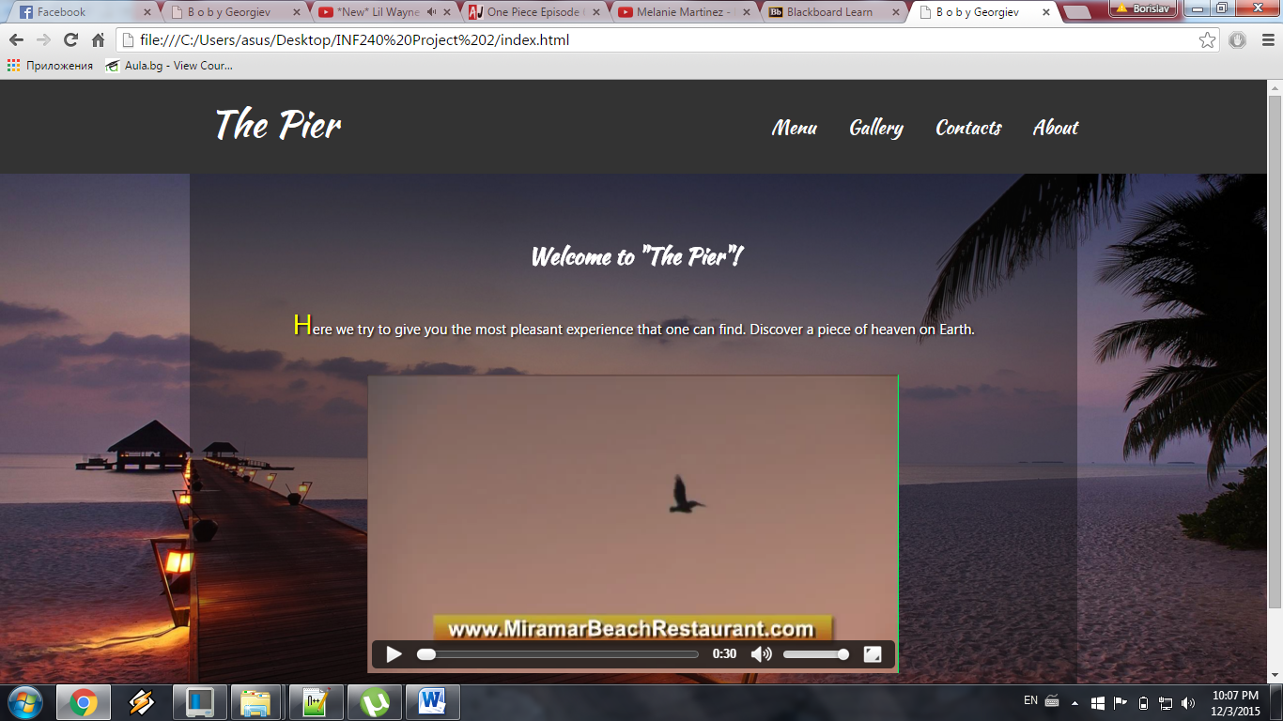

On this page there is a video about a restaurant much like the one I want to show through the website (though it’s different). The “video” tag actually is the reason why the page could not be verified at W3C. All 9 errors are because of the video.

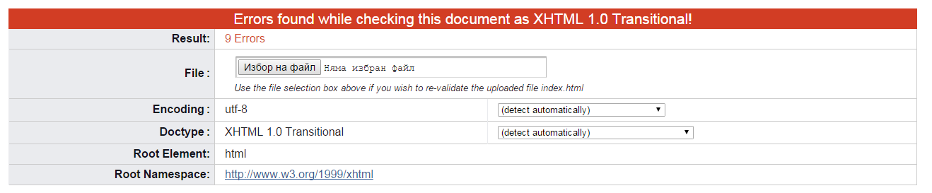

**The Menu Page**

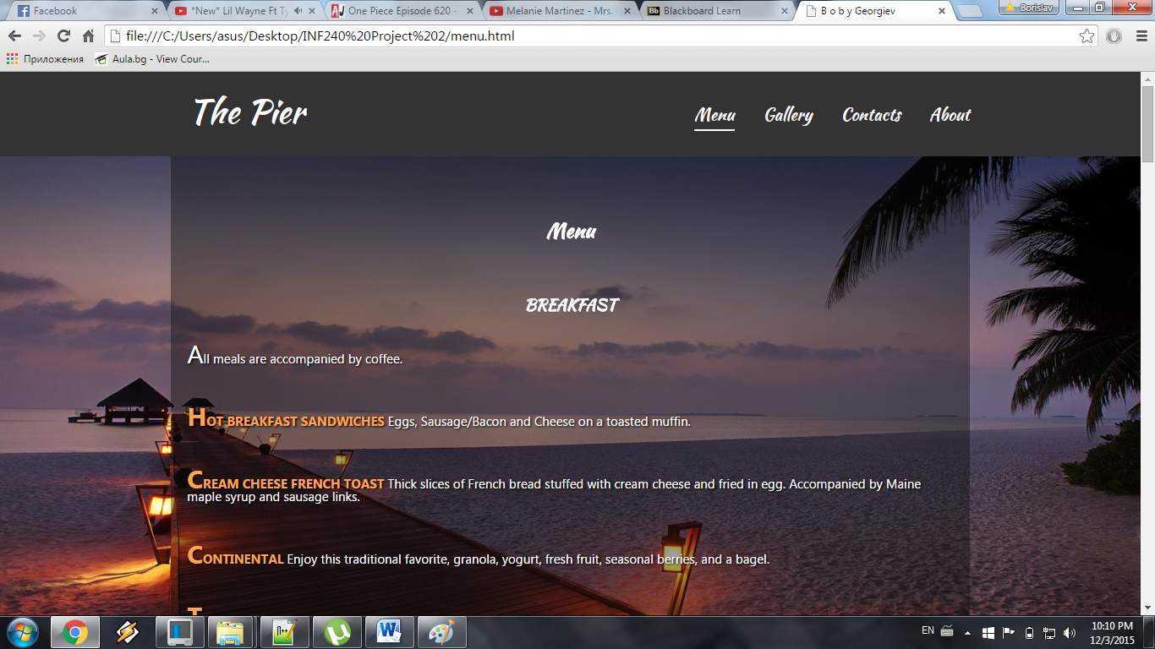

This page is pretty self-explanatory. It has “h” tags and a lot of paragraphs for all the meals that the restaurant provides.

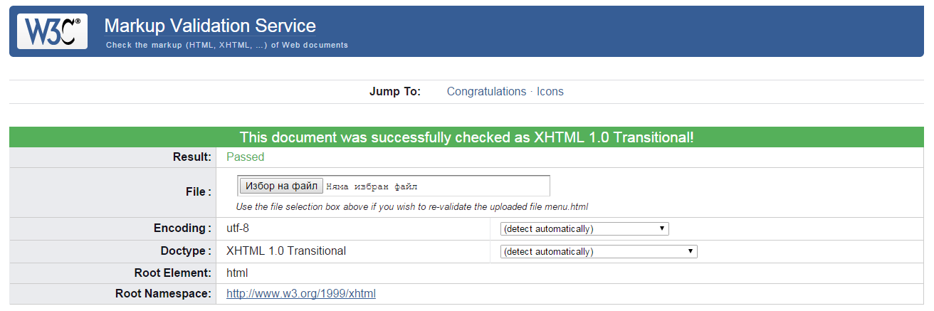

**The Gallery Page**

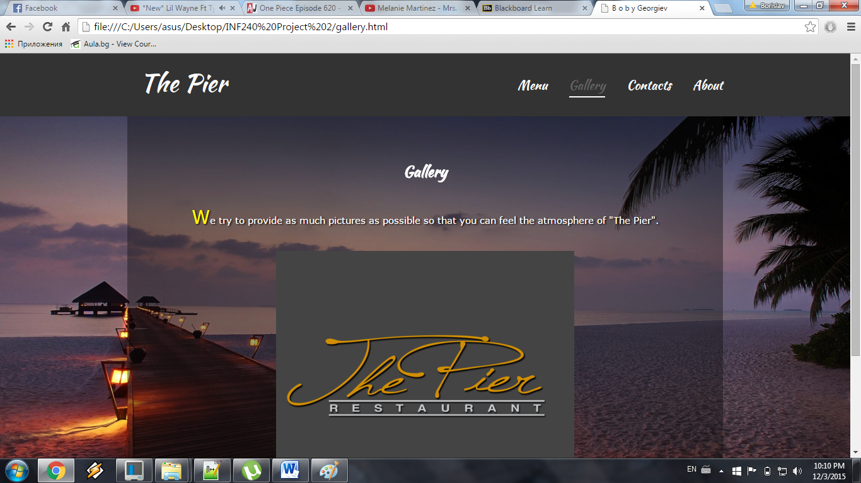

The different thing here is that instead of just placing the photos one after the other, I arranged them in a slider (the dark-grey rectangle in the middle of the page):

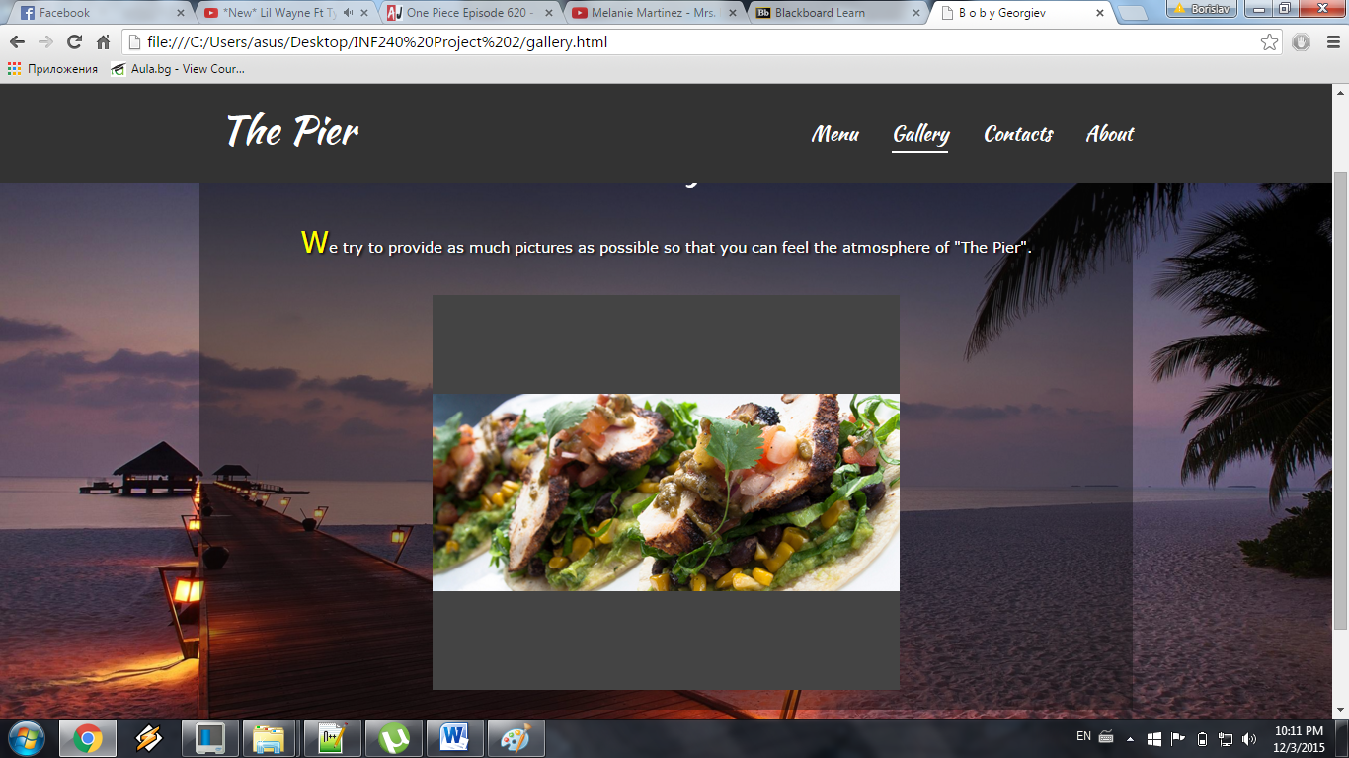

That is one of the images that get changed every 3 seconds. I used Javascript functions to achieve this effect.

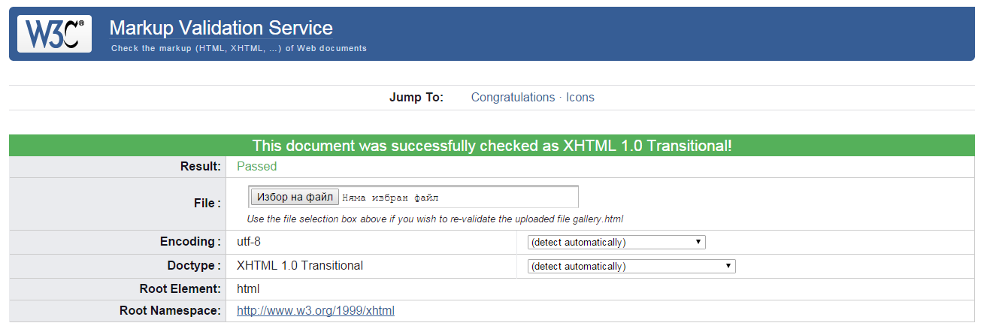

**The Contacts Page**

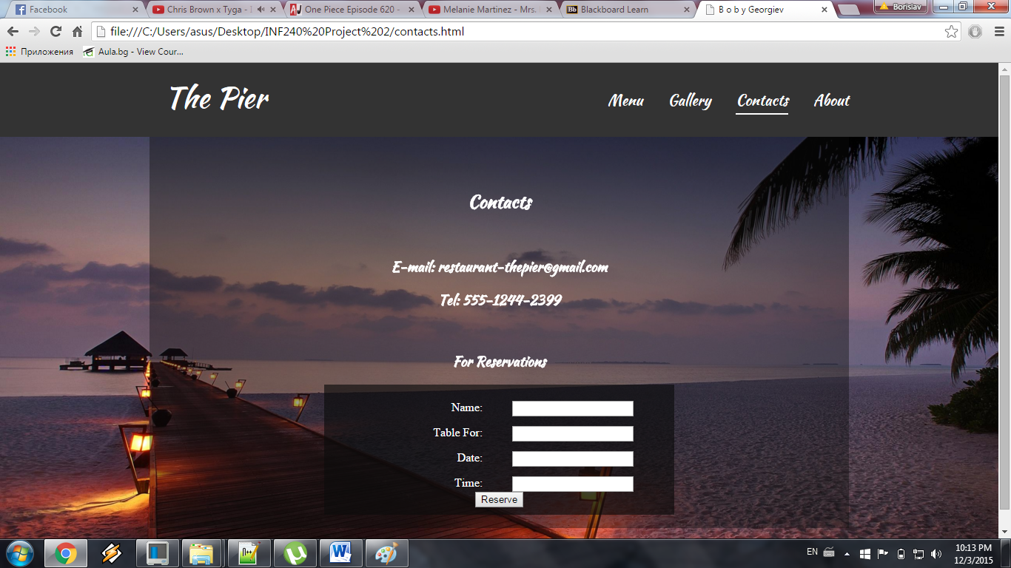

In this page there is some basic information about the restaurant (not real of course). There is also a form for the visitors to be able to make reservations through the website. The form has four fields – Name of the person, Table for a certain amount of people, Date for the reservation and Time of the reservation.

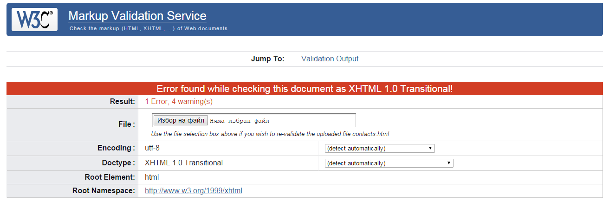

The error that occurs here is because there is no attribute “action” in the “form” tag. That’s because there is no place where the form will be processed (database or URL).

**The About Page**

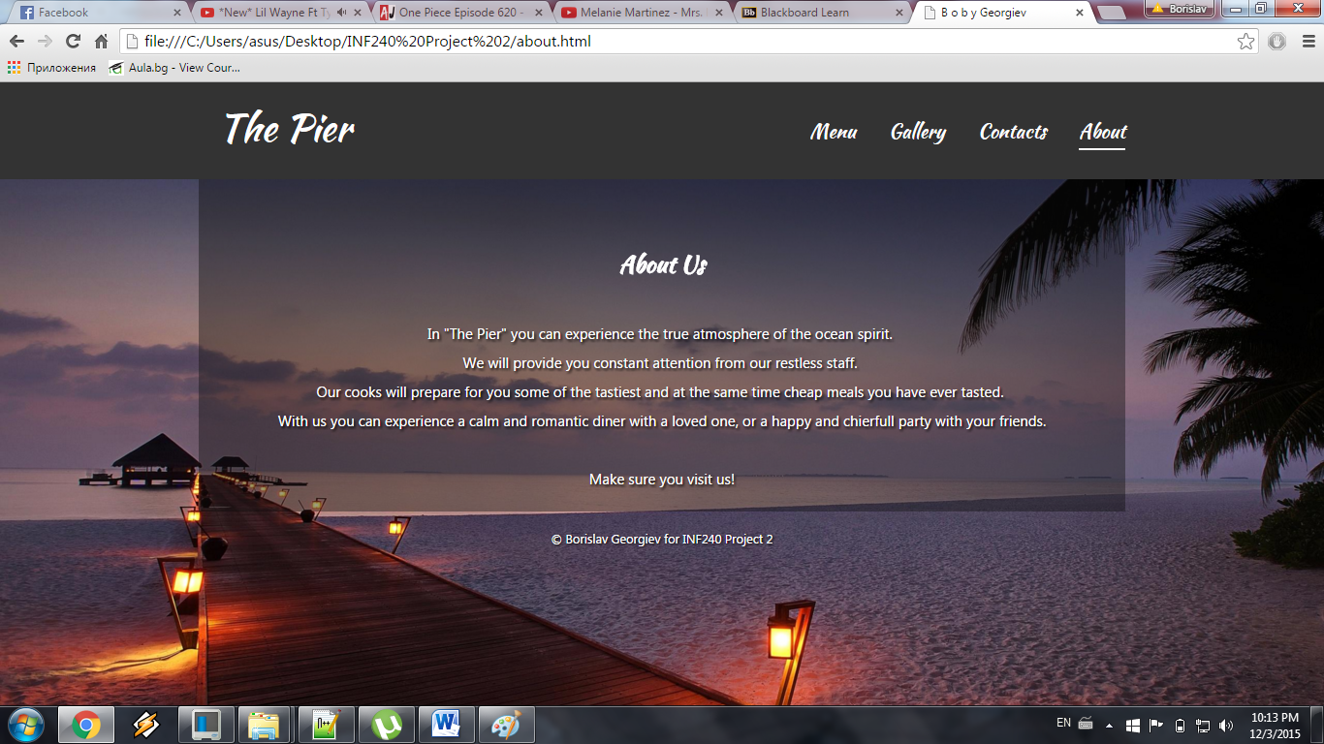

Again the About page is pretty straight forward because it has only plain information organized in “h” tags and paragraphs with breaklines.

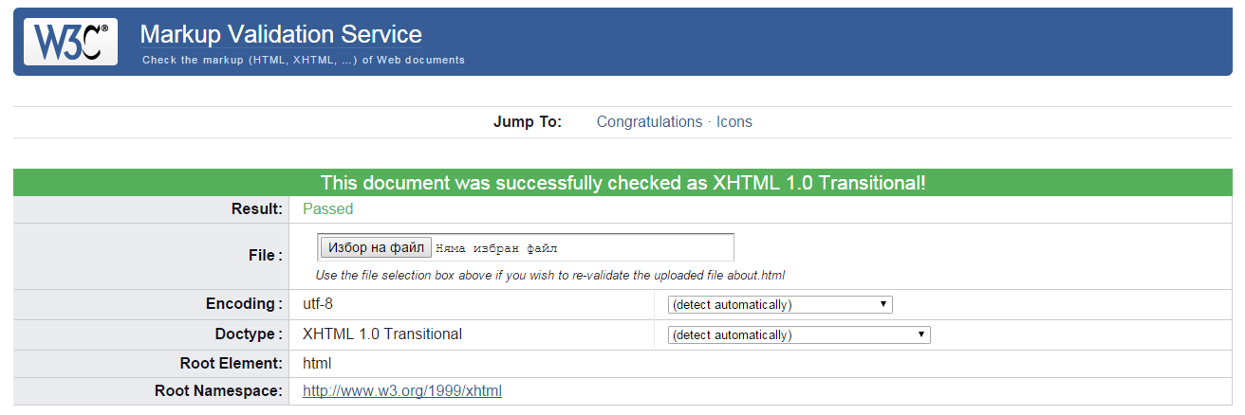

One more thing that is really good looking at least for me is the Responsive design of the header.

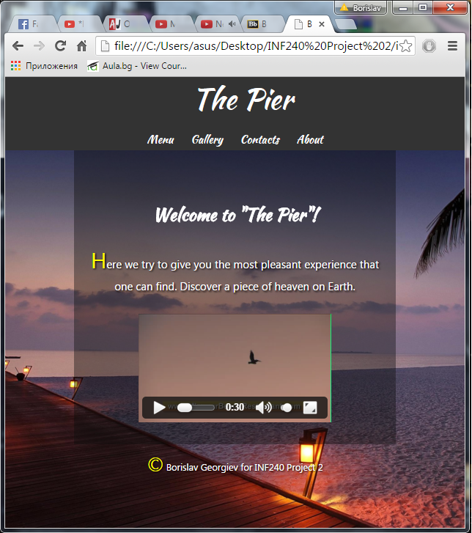

When we shrink it enough the logo gets centered at the top of the header and the navigation bar gets centered right under the logo. Again it takes 0.3 seconds so that it looks smoother.